**Exploratory analysis of the diamonds dataset**

**Q1.**



There are several attributes of diamonds such as carat, cut, colour and clarity.

In this dataset, in terms of cut, the best is ‘Ideal’ and the worst is ‘Fair’. In the values of colour. And the best colour is ‘D’ and the worst is ‘J’. In the meantime, the best diamond in the diamonds dataset has ‘IF’ as the value of clarity and the worst has ‘I1’.

**Q2.**

**\*Plot price and weight against the physical ordering of the data**

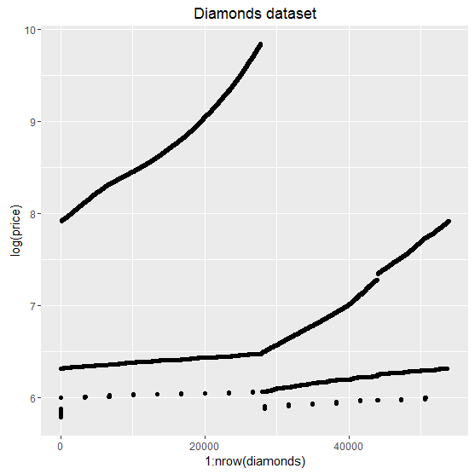

As a basic check, we can plot the dataset. It seems like there are some missing values.

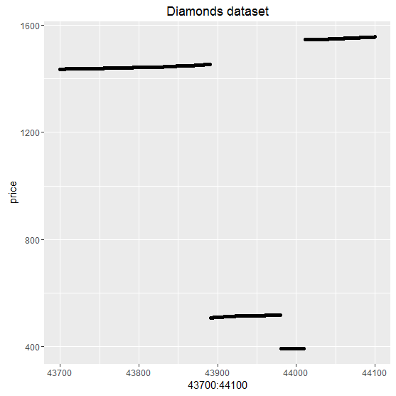

There is a missing range of prices around between 1400 and 1600. As I checked the dataset, it is figured out that the missing range of prices is between 1454 and 1546 precisely.

**\*Checking consistency of x, y, and z measurements with weight (carat)**



There are some outliers here. As an example, one of the point at the end of right side has the largest volume but the value of carat is only 2. Also, we can see a few points at the left edge along the y line, it has a volume almost 0, but the value of carats is much bigger than these volume.

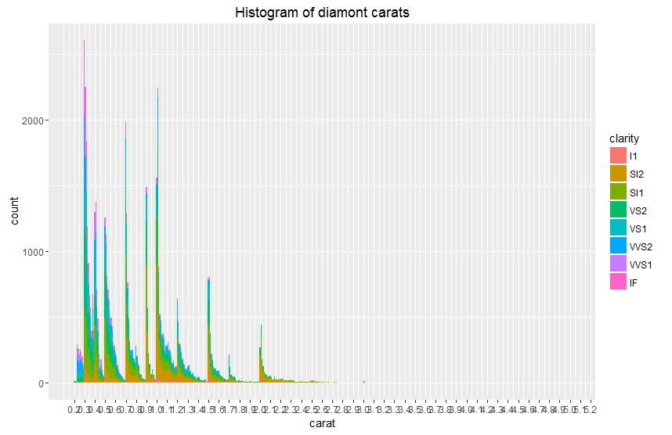

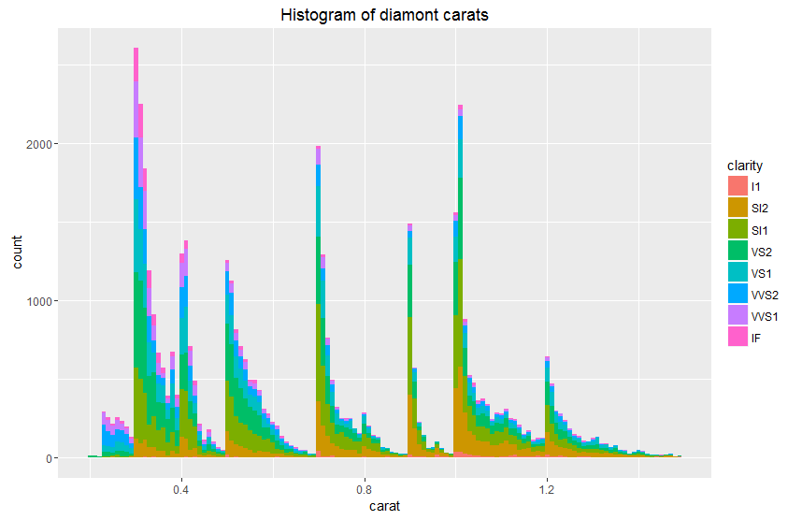

Without any surprising, there are many small diamonds than a few large ones.

**\*Checking the distribution of prices**

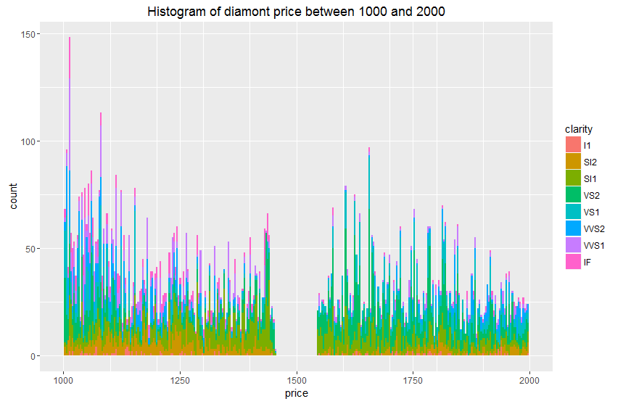

As we noticed before, there is a clear gap between the price of about 1450 and 1550. Surp

**\*How is weight (in carats) related to price?**

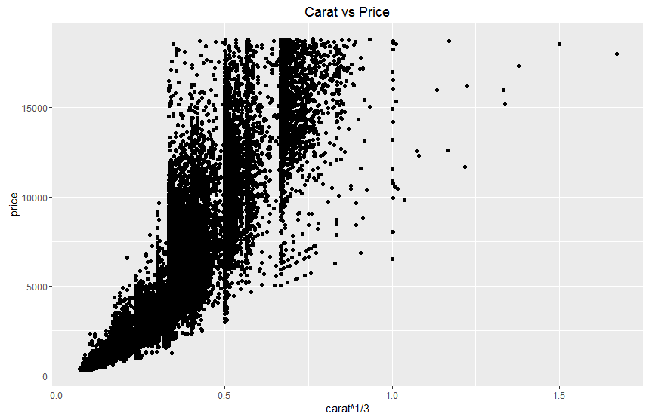

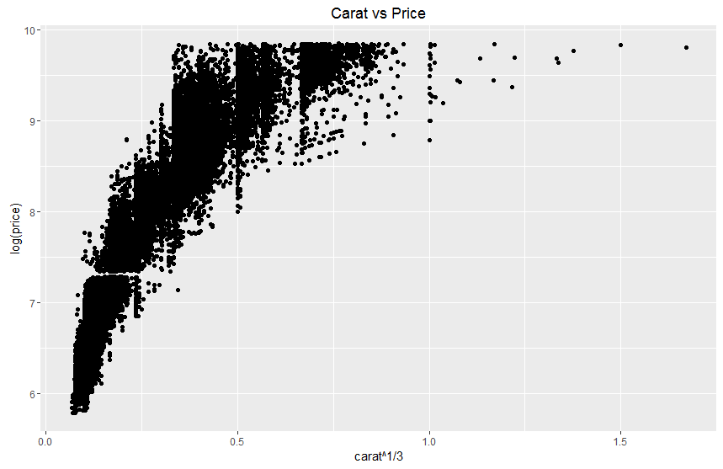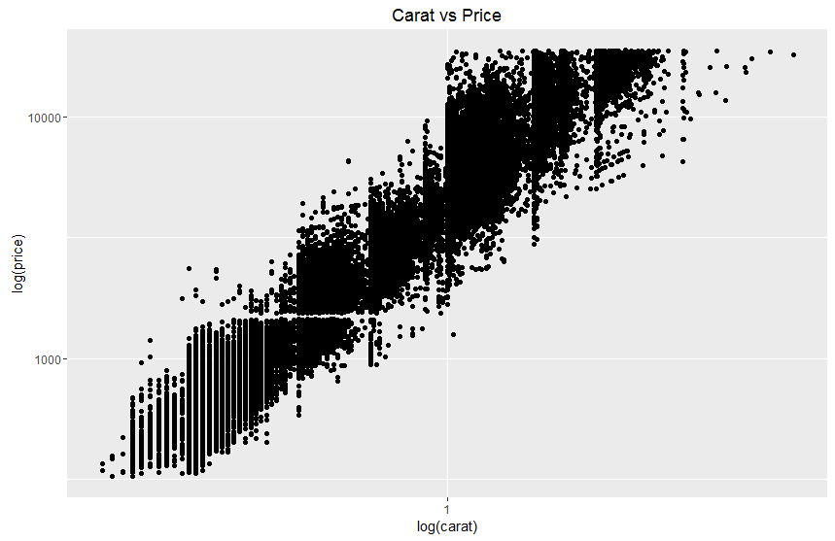

The log-log plot demonstrates a more straight line than the previous plots.

**\*What are the distributions of clarity, colour, and cut?**

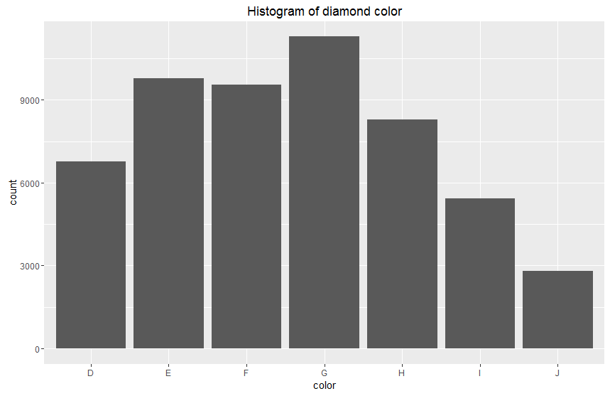

Most common type of colour is ‘G’, the average.

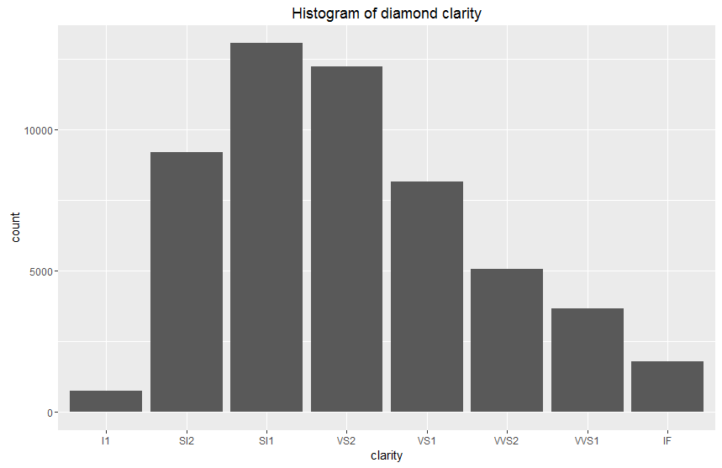

The levels of clarity ‘I1’ and ‘IF’ are rarer and there are many of diamonds with average clarity.

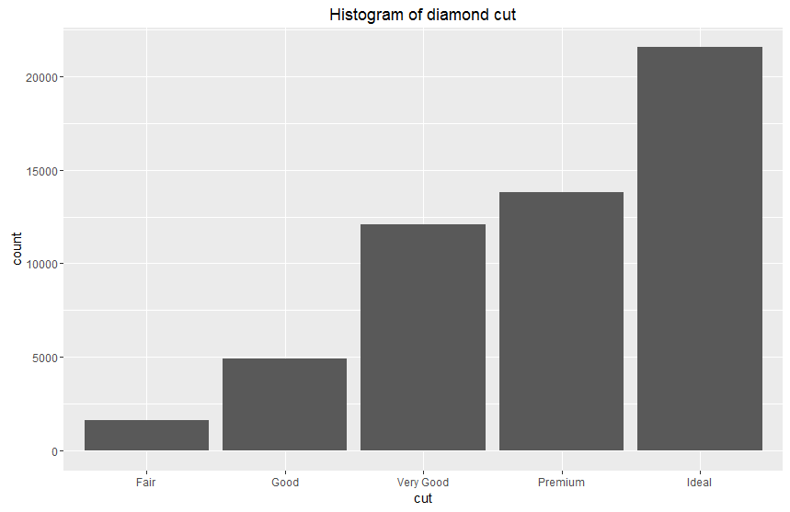

Interestingly, the majority of cut level is ‘Ideal’ and there is a linear relation between cut and count of diamonds.

**\*How do clarity, colour, and cut affect price?**





The best levels of clarity and color appear to have the lowest median prices, because clear diamonds are rare, so the size is small. The most affective attribute to price is the size. As a result, clear diamonds tend to be lower price. The geom_violin() was not very helpful to figure out the distribution of prices. In my opinion, geom_boxplot() is clearer to see the medians.

**\*Does the distribution of clarity, color, and cut change with carat-weight?**

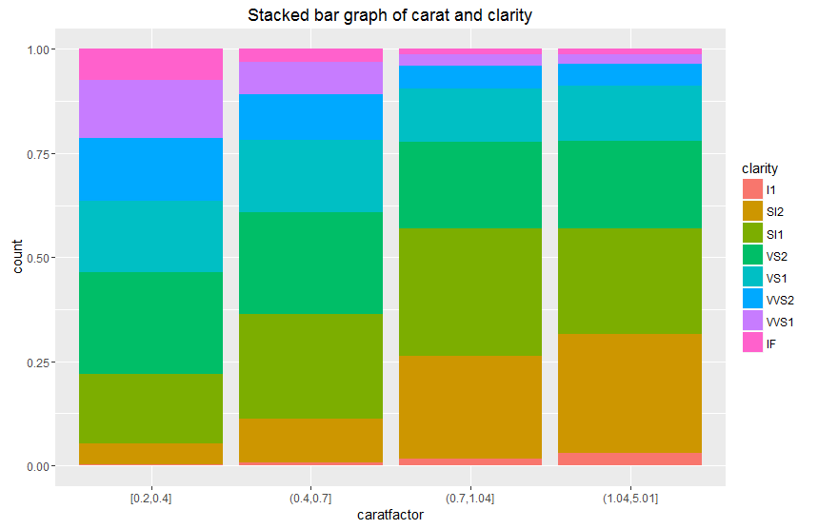

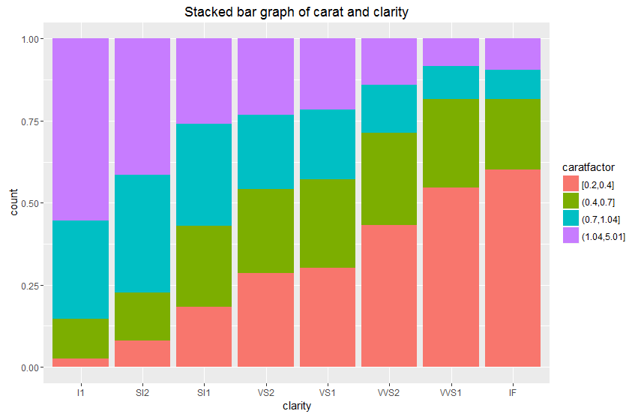

The high clarity diamonds are mostly small.

**\*The effect of clarity, colour, and cut on price: second attempt**

In ‘harfcaratdiamonds’ dataframe has 4536 observations. The ‘onecaratdiamonds’ subset has 9260 diamonds rows.







According to three graphs about price distributions for cut, clarity, and colour, clarity has the most powerful effect to price and cut also has some effect linearly to price.

**\*Is there any interaction between clarity, colour and cut in determining the price?**



A diamond tends to be high price when clarity is better.